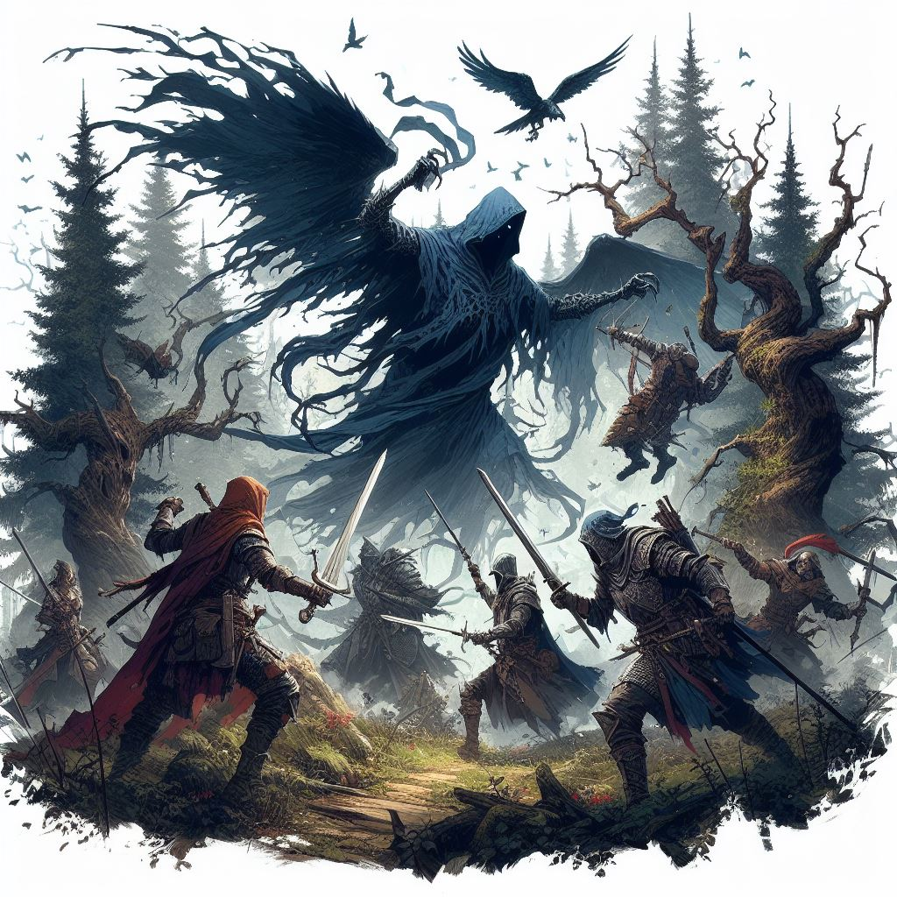





# Title Gradient 6Introduction

Welcome, Game Master! This book is for your eyes only. It contains the QuestGuard starter campaign Whispervale. It contains instructions on how to run this story campaign.

If you are not a Game Master, close this book immediately.

## Who Is This For

This book is intended for beginner Game Master and players who have never played QuestGuard. It was made to be as easy as possible to run.

If you have never been a Game Master, now is your chance.

## What To Expect

Whispervale follows a group of 3 to 5 players, on an adventure that will last (on estimate) 5 to 10 game sessions, depending on the group’s pace and duration of sessions.

As a Game Master, you are **not required to read this book in advance**. Whispervale was made to be **read at a glance** - it requires minimal preparation. However, please read everything up until Chapter 1

before you begin, to learn how to use this book. Once you get to Chapter 1, simply let the book guide you.

The book contains many read-aloud sections, and flows top-to-bottom, left-to-right and will guide you through everything you need to say and do.

This campaign also teaches the players the basic rules of QuestGuard in the first sessions.

It also teaches you, the Game Master, the rules for QuestGuard from a Game Master’s perspective.

## Your Responsibility

As a Game Master, you will be the narrator and referee of the game. You present situations, and players will try to do things in those situations. A lot of the times, a **Check** is required (a roll of a die).

You will be responsible for reading passages out loud for your players, roleplaying as non-player characters (e.g. speaking in the voice of another character or conveying what they are saying), controlling the monsters in fights (e.g. rolling dice for them) and, usually, making sure every player gets their shine in the spotlight and is having a good time.

# Title Gradient 6How To Read It

This section explains how to read the book and interpret various elements.

## Read-Alouds

When you encounter text with a tan background like this one, read it out loud for the players.



*This is some sample text.*

*It’s just an example.*

*Whenever you see this in the section you’re in,*

*read it out loud.*

There will be a lot of these and they will narrate not just story elements, but also rules.

As a Game Master, **a lot of the information you have will be from read-alouds**. These read-alouds will serve as information for both you and the players.

## 

## NPC Replies

In some sections, NPC’s (non-player characters from the story) will have potential replies to say. Here is an example for a random peasant players encounter:



***S:*** *Welcome to our village, adventurers!*

***S:*** *You look hungry. Head over to the tavern, they*

*serve good food!*

***Q:*** *I know nothing of* ***black magic artifacts*** *[truth].*

***Q (Earned)****: I never* ***stole*** *anything in my life! [lie,*

*he stole coins from the church donation box]*

You will see read-alouds with NPC replies.

Lines with **S** are meant to be **said** directly by the NPC (e.g. casually mentioning them in a conversation)

Lines with **Q** are meant to be only answers to **questions** players ask, and should not be given without being asked. If a line has **(Earned)**, then it means the players have to **earn** this information somehow, either through a die roll (a Check) or by bartering.

**Bold** phrases or words are emphasized to easily come into your view in case players ask about it.

## NPC’s - When In Doubt…

When in doubt of what an NPC would say, resort to them saying *“I don’t know”*. Perhaps if the NPC has authority over the players, they might say *“That doesn’t matter”*.

Don’t worry - you will get good information on NPC’s that is easily readable at a glance, without requiring preparation.

## Props

The campaign contains paper props, such as a map, secret letters, etc. Only give these out when instructed by the book. Keep them secret until t

# Title Gradient 6Story Breakdown

The story begins as soon as all the players are ready and have their characters finished.

This adventure follows the player characters exploring the gloomy town of Whispervale and fighting the forces of the vampire lord Sedrik, while struggling to rid themselves of a strange curse.

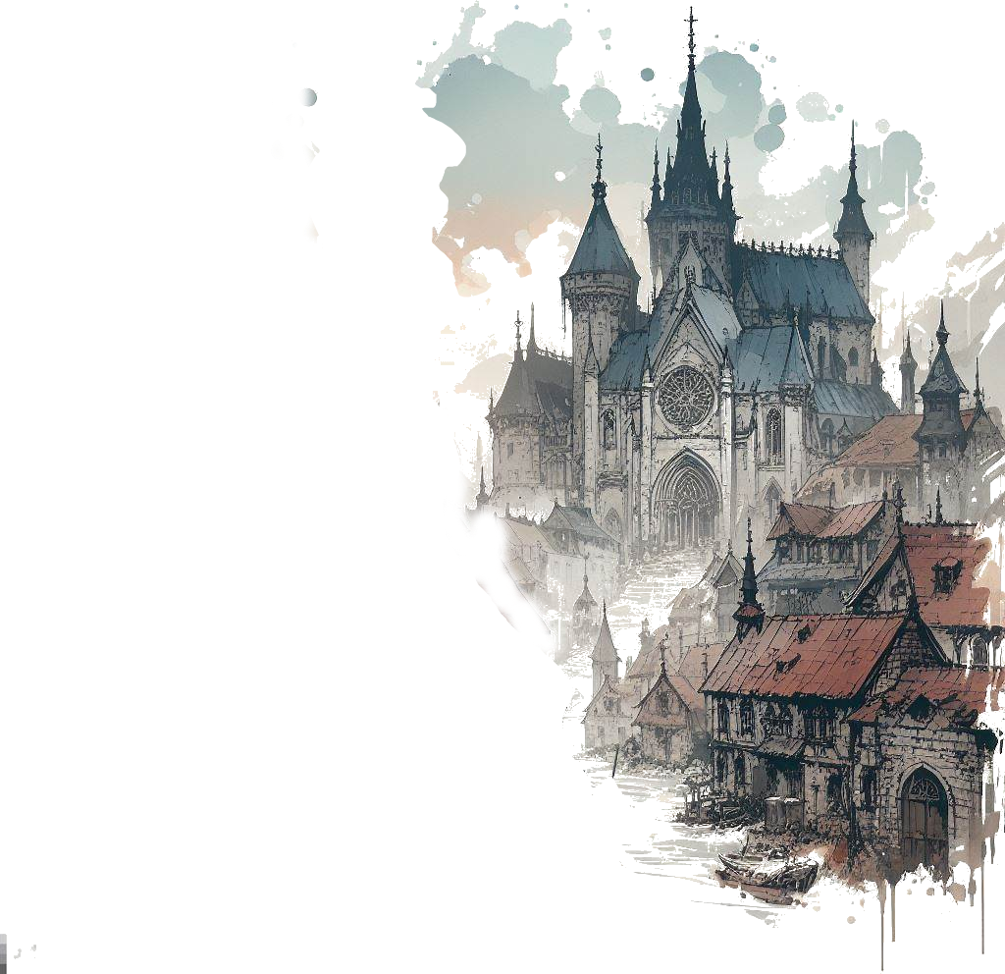It starts with the player characters escorting a priest to Whispervale. They are soon ambushed by a group of black ghosts, which they will have to defeat. Regardless of their victory, the ghosts curse the players.

The players will eventually get to Whispervale

and the story will unfold, revealing the secrets of lord Sedrik and of the inhabitants of Whispervale.

When you want to present the idea of

Whispervale to your players, read the following

out loud:



*Whispervale: a town at the edge of civilization*

*where you will discover a tapestry of secrets*

*woven into the very fabric of this town’s history.*

*Are the townsfolk merely succumbing to*

*paranoia, or does a palpable darkness truly lurk*

*beneath the surface?*

*These secrets are for* ***you*** *to unravel.*

*You will be playing the roles of fresh adventurers*

*exploring the small town of Whispervale and its*

*surrounding woods, rivers and meadows.*

*You will have to battle wicked monsters, interact*

*with the inhabitants of the town and piece*

*together clues to solve the overarching mystery*

*of Whispervale.*

*So ready your sword, find your notes and your map*

*markers, plan out accordingly, and immerse*

*yourselves in the story of Whispervale.*

You can give the players the extra information that they will play Level 1 characters and the theme, while not horror, has a tent of dark fantasy. There are (hopefully) no elements that would make the players uncomfortable:

There is no depicted gore or disturbing visual imagery in the book, not shown, nor told. There are no disturbing visuals and no topics that would be considered “taboo” in the real society.

However, the story can be gloomy, have the characters make morally gray choices, and contain potentially unsettling monsters (such as undead or spiders) or unusually looking people.

On the upside, the story provides props: maps, letters, clues and pictures of many locations and characters.

## Story Explained

The following is information that players will piece together throughout the campaign:

Lord Sedrik was a noble living in a mansion in Whispervale. He wanted the love of a mage, Mortessa, who was secretly practicing black magic. Lord Sedrik found out about it. She claimed she could make both of them immortal. Lord Sedrik wanted no such thing - black magic was unnatural.

The black magic practices were creating deep conflict in their relationship, as well as Mortessa’s secret rituals and dubious morality.

Mortessa held her opinion: “I can show you! I will show you!”. She cast a spell on Lord Sedrik and turned him into an immortal vampire through 1000 curse marks on his body, living him devoid of any bodily sensation and feeling depersonalized, like an empty vessel.

Sedrik was enraged at the sight of him having become an abomination and he attacked Mortessa, maiming her forever.

She fled, never to be seen again.

Lord Sedrik now resides somewhere in his lair and wants 2 things: to rid himself of the curses of vampirism, and to end all black magic in the region (including killing Mortessa).

Both Mortessa and Sedrik are villains in this story and seek to fulfil their goals by any means necessary.

After more than 200 years of study, Sedrik has finally discovered there is a way to remove the curse, and that is to transfer the 1000 marks to other people, one by one. However, only certain people can survive the curses. A cult has formed around Sedrik’s curse marks. Sedrik has also learned to use his vampiric abilities to subjugate and mind-control Mortessa’s undead in his favor.

Mortessa’s presence around Whispervale makes people age faster. She passively steals life from all creatures within several dozen kilometers of her location, and thus prolongs her life.

Her ultimate goal is immortality and wants to become a lich by gathering eldritch artifacts and siphon them in her ritual. She uses her own undead creations, her dragon and her minion goblins to gather the last few needed pieces of her plan.

Neither Mortessa nor Sedrik knows where the other is hiding.

## Players’ Progression

Players start escorting Father Alan, a priest, to Whispervale when they get ambushed by black ghosts, inflicting players with 1 of the 1000 curses of Sedrik.

A Witch named Riven can cure their curse with a magical lamp they will need to retrieve for her.

Players will also investigate Sedrik’s old mansion, where a different monster now resides. They will meet Sedrik face-to-face and find clues about where Mortessa lives.

They will go after Mortessa and end her life draining, and finally, they will find Sedrik’s hiding place and deal with him.

Of course, this is not as straightforward as it seems - players will have to talk to NPC’s, survive fights with undead, solve puzzles and mysteries and make their way through.

Whispervale also contains a lot of side quests, that are completely optional but are all tied to the main mission. Players can do these side quests to reveal more of the story (or more sides of the story) and for extra items, experience and gold.









# Title Gradient 6Introduction

Use this template for homebrew. It is similar to what the final version of the book will look like.

You’re free to edit and adjust it to your liking.

You have all the specifications in the README file.

The font used is LinuxLibertine (you will have to install it on your computer).

Select this text together with the chapter section, copy it and paste it.

The underline should be 5 pixels below the ‘p’ immediately after the graphic goes below the chapter section.

The Chapter Section should always be on the left.

Always use copy paste for these elements to preserve the format.

## Subsection

This is a subsection. No special rules.

## Background & Details

After you’re done with a page, you can copy and paste the gradient from the top and bottom of the page.

## Title Text

For a main title (like QuestGuard), use the PSD template on <https://photopea.com> (or Photoshop) to create your title. Create a new text based on the specifications with the text tool, then overlay letters one by one over your font letters. Then delete the text and keep only the overlapped letters.

Oh yeah, and you need to load the Eczar font into Photoshop.

## Readme

For the specifications of the font, document, etc, see the README file.

Chapter Section

This is an alternative look for the Chapter Section.

## Supsection

This is another example of a subsection with some normal text, and following it is an aside box.

You can use this for **read-aloud text**.

*Here we have a nice little aside box. Use*

*Calibri* ***Italics 10.5px*** *when working with this.*

*By the way [this is not meant to be read aloud].*

*Also, leave 1 space of indentation to the left.*

*And make sure there is enough space on the right.*

*This text is just a continuation of the text*

*above, in a different font.*

Feel free to resize the aside box background as you see fit. Also, here is a list, also Calibri I. 10.5px:

* *Small lamp*
* *25 gold in leatherworking materials*
* *Shortsword*

That was a list. Use copy/paste to paste the list.

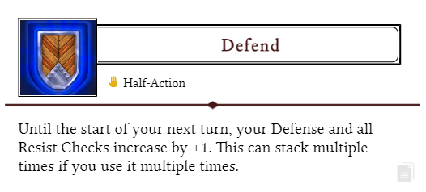

That was an Ability from the website (using the copy/paste button from the Ability box).

## Artwork

This text works

great with the goblin

on the right side of the

screen and the artwork

fits well. Lorem ipsum

dolor sit amet tristique

delirium sumus but take

into consideration that

the text should be

just long enough to fit here

nicely. The easiest way to

add artwork like this is to just

set its box to “behind text” and

you will be able to move

it around without doing

anything wicked to the

text, and gives you full control of

how you position your text. Use

spaces and enter with courage,

lads!

## Tables

Copy and paste this table when you want to create one. Pretty simple.

|  |  |  |
| --- | --- | --- |
| **Dice Roll** | **Description** | **Effect** |
| 1 | Stun | Target skips its next turn |
| 2 | Slow | Target has -2 Movements |
| 3 | Charm | Still not sure to this day |
| 4 | Exhausted | Half movement & actions |
| 5 | Fumbling | -2 to all rolls |
| 6 | Dazed | Halved actions, sir! |

That was a table. The background gradient is just an image, good luck moving it. If your table is on the left, you might want to flip the gradient for the rows.

